|  |
| --- |
| Neighborhood Battle-London and Newyork  2019 |
|  |
| August 11  Authored by: Sharmila |

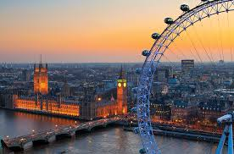

# Table Of Contents

# Title……………………………………………………………………PageNo.

# Introduction…………..……………………………………………………….3

# Data……………………………………………………………………………3

# Introduction

# The intention of this project is to compare London and Newyork. The analysis would be done based on various list of venues generated by the foursquare API in these neighborhood

# to determine which neighborhood is better for tourist. The analysis would be done based on the various aspects which could make it comfortable for a tourist.

# Data Section

# The following data sets, which includes data from Wikipedia and the other open source data in .csv formats would be highly appropriate, extensive and helpful in analyzing and visualizing data in determining which is the better neighborhood for tourist.

# <https://en.wikipedia.org/wiki/List_of_postcode_areas_in_the_United_Kingdom>

# ukpostcodes.csv

# Postcode_districts.csv

# <http://freakonometrics.free.fr/popfr19752010.csv>

# Hate_Crimes_by_County_and_Bias_Type__Beginning_2010.csv

# tourism-trips-borough.csv

# ukpostcodes.csv

# Essex_County_Tourist_Attractions.csv

# recrime-geo-pfa.csv

# NYPD_Shooting_Incident_Data__Year_To_Date_.csv

# international-visitors-london-raw.csv

# NYPD_Complaint_Data_Current.csv

# 